**LAB-10**

**Multiplexer/ DE multiplexer Decoder**

**Equipment/Components**

**Hardware:** Explorer Board

IC Type 7408 Quadruple 2-input AND gates

IC Type 7486 Quadruple 2-input XOR gate

IC Type 7432 Quadruple 2-input OR gates

IC Type 7404 Hex Inverter

**Software:** Circuit Maker, Waveform

**Description**

In this lab combinational logic circuits are implemented using ‘and’ ‘or’ and ‘not’ gate on Circuit Maker and Explorer Board. After the lab students will be able to understand the functionality of Mux and De Mux, and how to implement the circuit for BCD to Seven Segment Decoder.

**Objectives**

* To learn and understand the working of Mux and De Mux.
* To Implement **BCD to Seven Segment Decoder** onHardware.

**Task # 1**

1. For 2 inputs multiplexer connect the circuit on Circuit Maker, Draw truth table and write

their equations and verify results (see lecture notes for help).

|  |  |
| --- | --- |
| S | Y |
| 0 | I0 |
| 1 | I1 |

**CIRCUIT MAKER:**

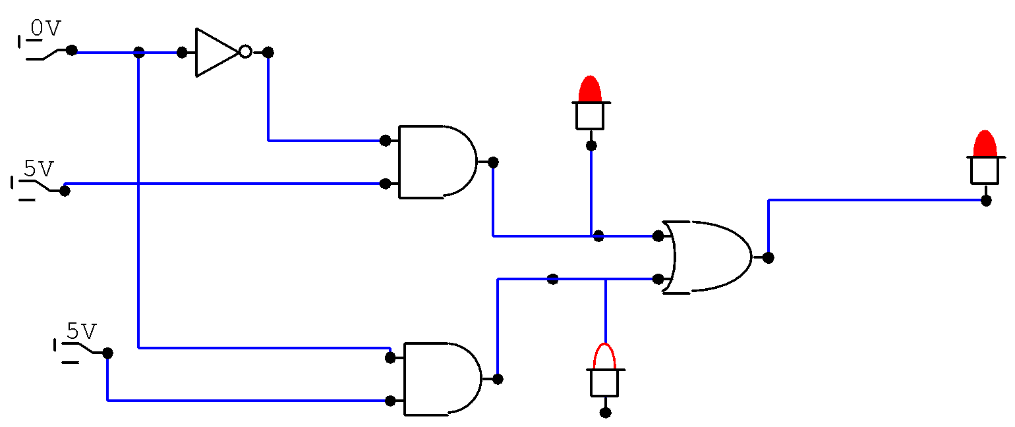

**EQUATIONS:**

**I0.S’+I1.S**

1. For 4 inputs multiplexer connect the circuit on Circuit Maker, Draw truth table and write their equations and verify results (see lecture notes for help).

|  |  |  |
| --- | --- | --- |
| S1 | S0 | Y |
| 0 | 0 | I0 |
| 0 | 1 | I1 |
| 1 | 0 | I2 |
| 1 | 1 | I3 |

**EQUATION:**

**S1’.S0’.I0+S1’S0I1+S1S0’I2+S1.S0.I3**

**CIRCUIT MAKER:**

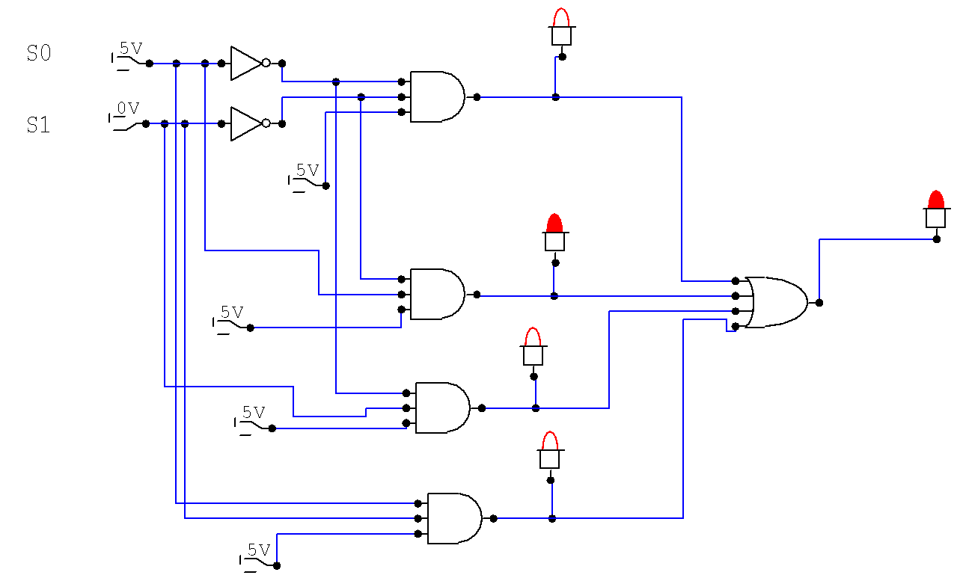

1. For 8 inputs multiplexer connect the circuit on Circuit Maker, Draw truth table and write their equations and verify results (see lecture notes for help).

|  |  |  |  |
| --- | --- | --- | --- |
| S2 | S1 | S0 | Y |
| 0 | 0 | 0 | I0 |
| 0 | 0 | 1 | I1 |
| 0 | 1 | 0 | I2 |
| 0 | 1 | 1 | I3 |
| 1 | 0 | 0 | I4 |
| 1 | 0 | 1 | I5 |
| 1 | 1 | 0 | I6 |
| 1 | 1 | 1 | I7 |

**EQUATION:**

**S2’.S1.’S0’.I0+S2’S1’S0.I1+S2’S1S0’.I2+S2’S1S0.I3+S2S1’S0’.I4+ S2S1’S0.I5+ S2S1S0’.I6+ S2S1S0.I7**

**Circuit maker**

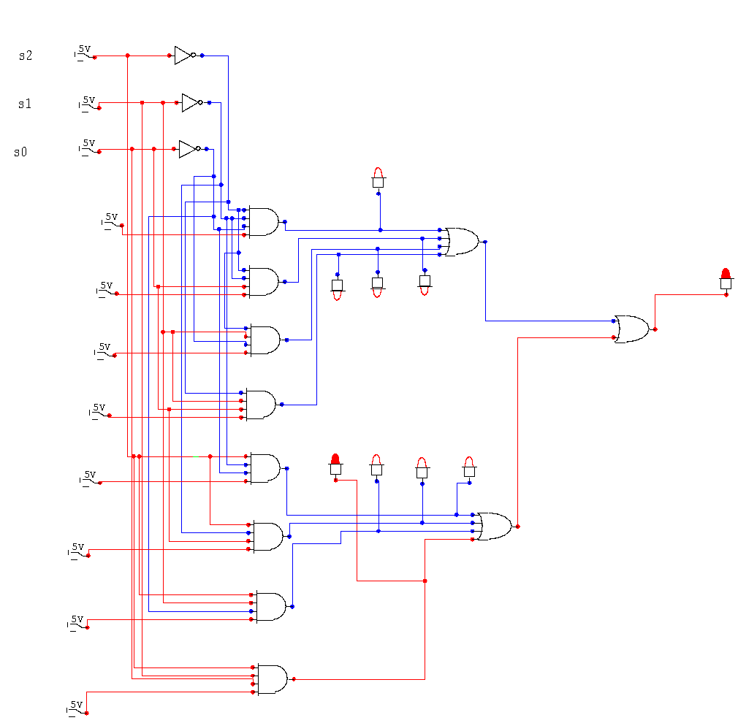

1. Implement the circuit in part (b) on explorer board and verify the truth table.

**Task # 2**

1. For 2 inputs DE multiplexer connect the circuit on Circuit Maker, and verify (see lecture notes for help).

|  |  |  |  |
| --- | --- | --- | --- |
| I | S | D0 | D1 |
| 1 | 0 | 1 | 0 |
| 1 | 1 | 0 | 1 |

EQUATION:

IS’+IS

CIRCUIT DIAGRAM:

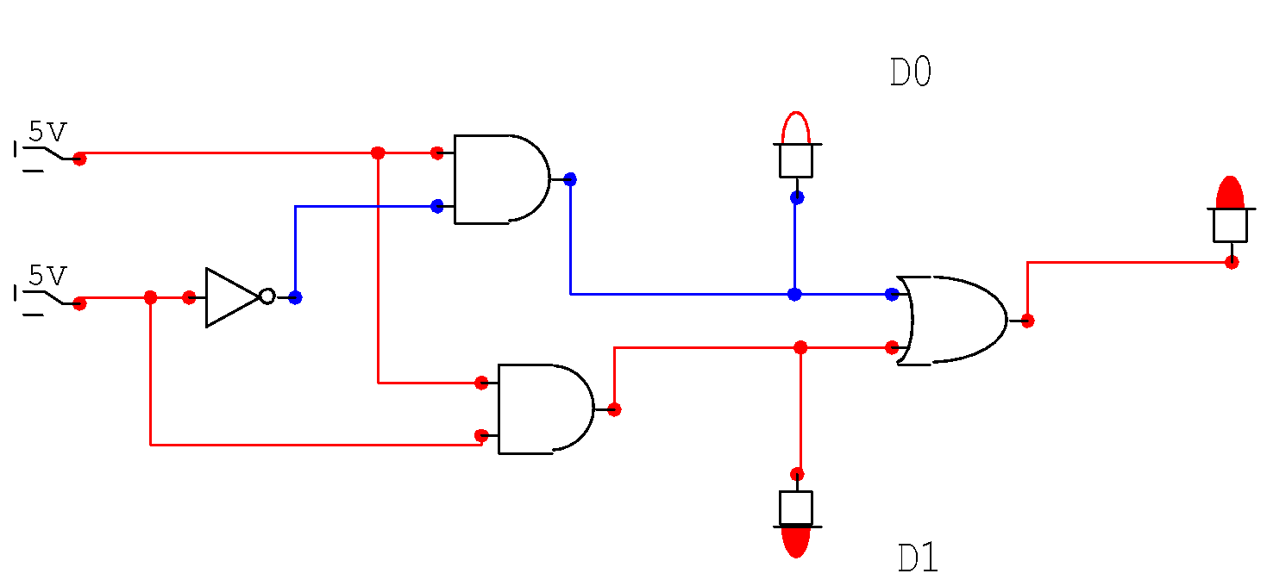

1. For 1-to-4 line DE multiplexer connect the circuit on Circuit Maker, Draw truth table, write their equations and verify results (see lecture notes for help).

|  |  |  |  |  |  |
| --- | --- | --- | --- | --- | --- |
| S0 | S1 | D0 | D1 | D2 | D3 |
| 0 | 0 | 1 | 0 | 0 | 0 |
| 0 | 1 | 0 | 1 | 0 | 0 |
| 1 | 0 | 0 | 0 | 1 | 0 |
| 1 | 1 | 0 | 0 | 0 | 1 |

Equation:

S0’S1’.1+S0’S1.I+S0S1’.I+S0S1.I

CIRCUIT DIAGRAM:

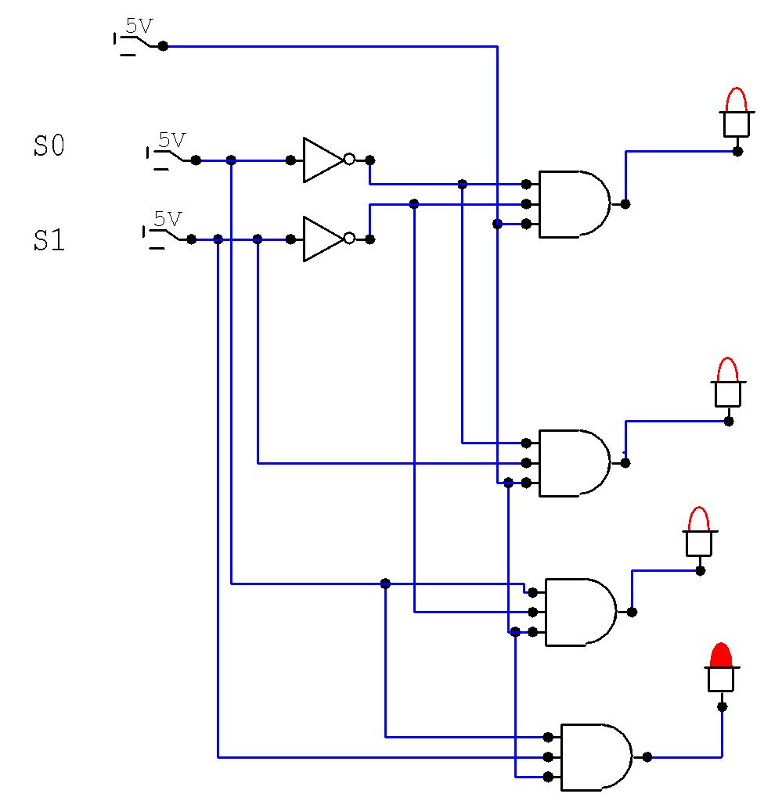

1. For 1-to-8 line DE multiplexer connect the circuit on Circuit Maker, Draw truth table, write their equations and verify results (see lecture notes for help).

|  |  |  |  |  |  |  |  |  |  |  |
| --- | --- | --- | --- | --- | --- | --- | --- | --- | --- | --- |
| S2 | S1 | S0 | D0 | D1 | D2 | D3 | D4 | D5 | D6 | D7 |
| 0 | 0 | 0 | 1 | 0 | 0 | 0 | 0 | 0 | 0 | 0 |
| 0 | 0 | 1 | 0 | 1 | 0 | 0 | 0 | 0 | 0 | 0 |
| 0 | 1 | 0 | 0 | 0 | 1 | 0 | 0 | 0 | 0 | 0 |
| 0 | 1 | 1 | 0 | 0 | 0 | 1 | 0 | 0 | 0 | 0 |
| 1 | 0 | 0 | 0 | 0 | 0 | 0 | 1 | 0 | 0 | 0 |
| 1 | 0 | 1 | 0 | 0 | 0 | 0 | 0 | 1 | 0 | 0 |
| 1 | 1 | 0 | 0 | 0 | 0 | 0 | 0 | 0 | 1 | 0 |
| 1 | 1 | 1 | 0 | 0 | 0 | 0 | 0 | 0 | 0 | 1 |

1. Implement the circuit in part (b) on explorer board and verify the truth table.

**Task # 3. Construct a 1-to-8 lines De Mux using two 1-to-4 lines De Mux.**

Help. Draw block diagram, create function table, write corresponding Boolean expressions and finally implement circuit diagram.